/* Ashok Rathod

Mock Interviews

9.10.19*/

Pics for auto mocks as per needed.

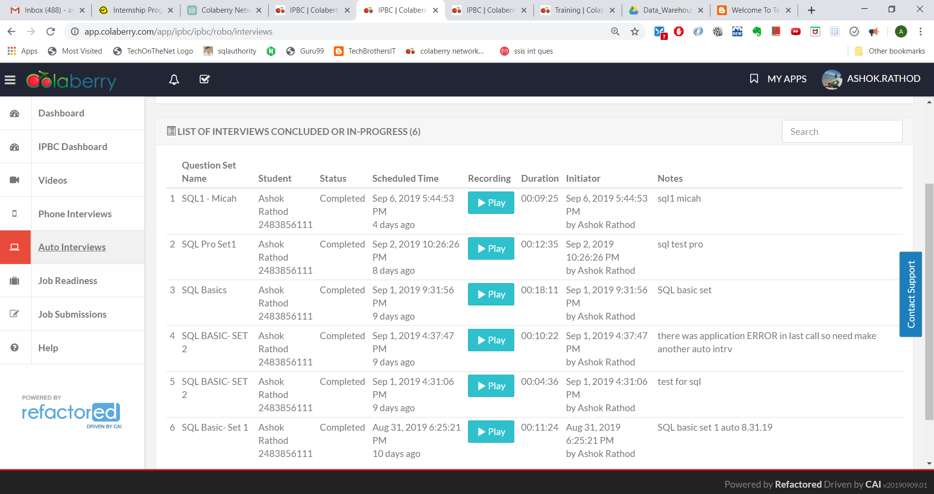

**Auto mock interviews.**

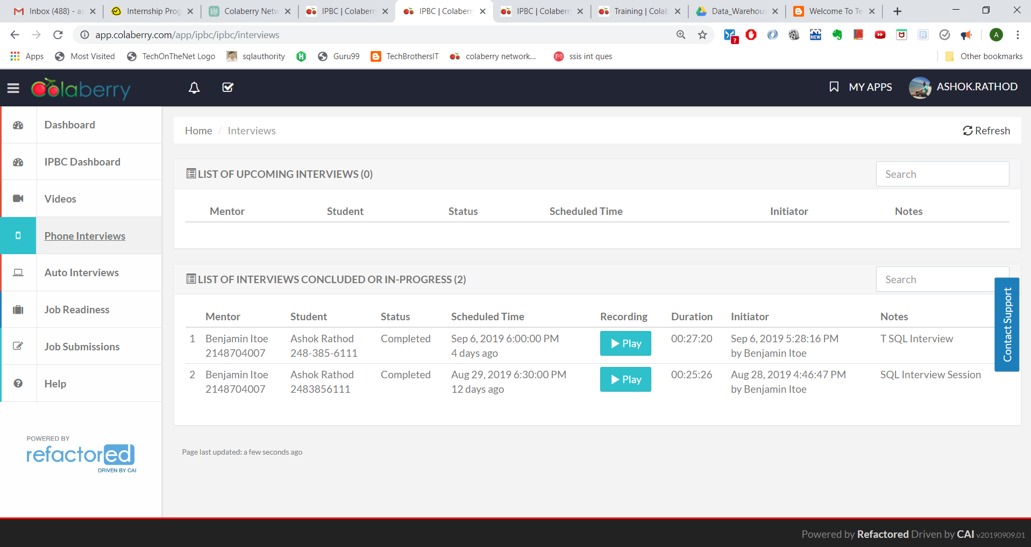

**Interviews with Mentor.**